BEACH VOLLEYBALL NATIONAL TOUR HOMOLOGATION

.......................................................
(Tour’s title)

In order to obtain the National Tour homologation by the organisations concerned, this form must be sent via e-mail from the hosting NF and Promoter to the Continental Confederation concerned at least 30 days before the start of the National Tour for its approval.

If approved, the Confederation concerned will then forward such a form at least 20 days before the first event of the National Tour, to the FIVB for its consideration. The FIVB, once approved, will send this form duly signed and sealed to all the parties concerned as well as it will post the related information on its website. The organizers commit to abide to the FIVB regulations approved by the World Congress and Board of Administration concerning the Beach Volleyball National Tours.

MINIMUM REQUIREMENTS
Minimum 3 legs
Note: The FIVB may also homologate National Championship with only one or two event(s) as a National Tour.
Enforced official FIVB Rules of the Game 2021-2024
Minimum 16 teams per gender’s event
Ball – Homologated ball by the FIVB
Mandatory use of the VIS platform
World Ranking Points (National Tour points) allocated in accordance with the FIVB Ranking points upon entering events, participating teams, and results through the VIS on the last day of each FIVB recognized event
Prize Money - Recommended

Important Regulations

- The events must be properly entered on the FIVB VIS platform, including participating teams, matches, results and then properly closed on the FIVB VIS platform. Otherwise, no FIVB Ranking points will be allocated.
- You must check and inform the FIVB Beach Volleyball Department (beachvolleyball@fivb.com) on the first working day after the event (before 13:00 Swiss time latest), that the event has finished and closed on the VIS platform.
- The name of another sports organization or promoter cannot be featured in the title of a National Tour (unless approved by the FIVB)
- For the international players’ participation in National Tour, the hosting and participating National Federations are required to abide by the Sports Regulations and in particular:
- Only registered athletes being in good standing with the FIVB and with the respective NF may take part in a National Tour.
- Foreign players may be invited in writing to a National Tour only through the host NF to their NF.
- International players’ participation should be agreed between the hosting NF and the participating NF, with written endorsement issued by their NF.
- To have a maximum of 25% of foreign athletes out of the entire number of athletes participating in the full roster (including Main Draw and Qualification) in each of the FIVB homologated National Tour leg. (As per the Sports Regulations)
- In case of a clash with the FIVB/VW Beach Volleyball Senior World Championships, FIVB/VW Beach Volleyball World Tour Finals and/or VW Beach Pro Tour), athletes from the top 32 ranked teams per gender per the FIVB World Rankings at 30 days before an event, except the hosting country teams, cannot take part in such a National Tour leg unless authorized by the FIVB in writing. For further information, please see the link: https://www.fivb.com/en/beachvolleyball and FIVB Sports Regulations.
- Foreign teams can only be featured with the names of the athletes while they cannot be promoted as representatives of their country.
- The Host National Federation is not allowed to create VIS profiles for international athletes that are participating in their national events. If an international athlete (different nationality) is participating in their National Tour, the Host National Federation must first consult with the National Federation of Origin of the Athlete.
- Players taking part in non-sanctioned events will do so at their own risk. If applicable the FIVB Sports Regulations and another regulatory framework may be applied.
- Youth/Junior National Tours must also undergo through the above homologation process if the organizers are willing to invite foreign teams.

PROMOTER (if any) | Address and phone:  Promoter Web site link to the event (if any):
NATIONAL FEDERATION | Full name & Address:  Person in charge of the competition software (VIS):  Name:  Email:  Phone:
VOLLEYBALL CONTINENTAL CONFEDERATION | Confédération Européenne de Volleyball(CEV)  488, route de Longwy  L-1940 Luxembourg  Luxembourg (LUX)
No | Dates  (DD.MM.YYYY) | Place | Category  (Senior/Junior/Youth) | Gender  M / W | Prize Money (in Euro) | FIVB USE ONLY  World Ranking Points Awarded
1.
2.
3.

Please attach additional information of the event including competition format, number of teams and relevant information in order to assist the parameters on the VIS.

If you plan to have more than 25% of International player participation in one or more of your National Tour events, please indicate below:

No | Dates  (DD.MM.YYYY) | Place | Category  (Senior/Junior/Youth) | Gender | Number of Foreign Players
1.
2.
3.

Please fill the below table with the name and FIVB number of any eventual top world ranked athlete participating in the National Tour in case of a tournament clashing with an FIVB Beach Volleyball event.

Name:

FIVB Number:

Tournament(s) the athlete participates in

Please send the dedicated form for the participation of top ranked athletes in tournaments clashing with an FIVB Beach Volleyball event.

CONTINENTAL CONFEDERATION FIVB

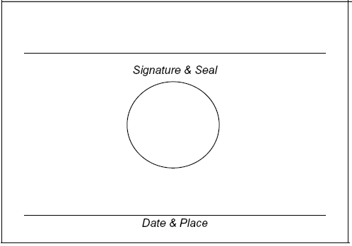

NATIONAL FEDERATION PROMOTER (if any)

